I have used R tool and ggplot library for generating all graphs in this assignment.

**DECLARATION:** I understand that this is an **individual** assessment and that collaboration is not permitted. I have read and I understand the plagiarism provisions in the General Regulations of the University Calendar for the current year, found at <http://www.tcd.ie/calendar>. I understand that by returning this declaration with my work, I am agreeing with the above statement.

**Part 1:** Plot to visualize the evolution of Life Expectancy (position encoded on y-axis) over the Years (position encoded on x-axis). Then I have created the below 3 variants of this chart

**a: Using Colour as channel to encode Continents.**

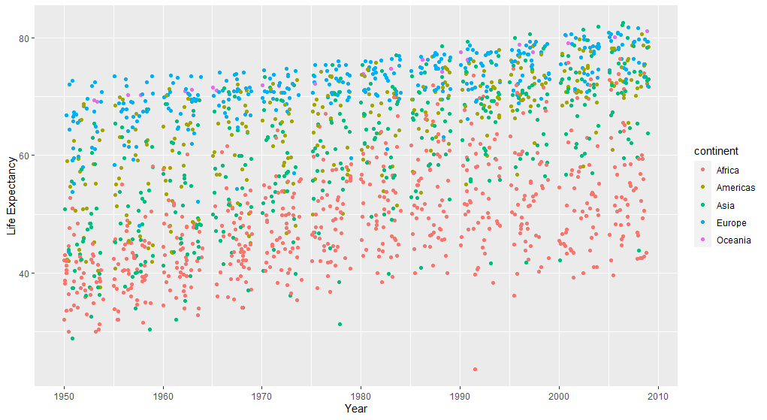

**b. Using Shape as channel to encode Continents**

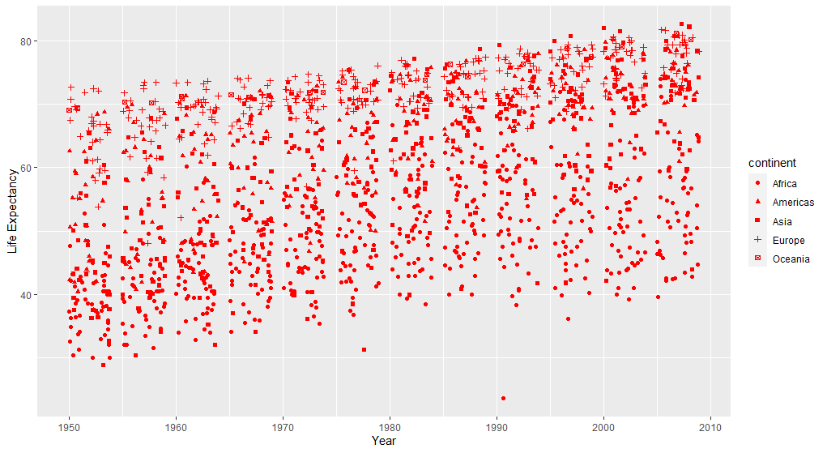

**c. Using Brightness as channel to encode Continents**

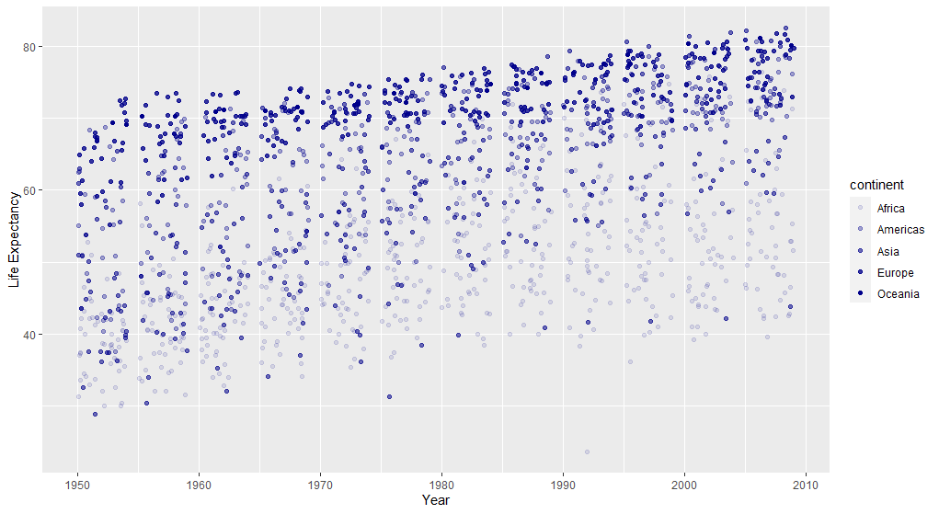

**Part 2:** Plot to visualize the correlation between Health and Wealth by plotting Life Expectancy (position encoded on y-axis) and GDP (position encoded on x-axis). Then I have created the below 3 variants of this chart

**a: Using Size as channel to encode Population. Larger population is encoded using bigger bubble size**

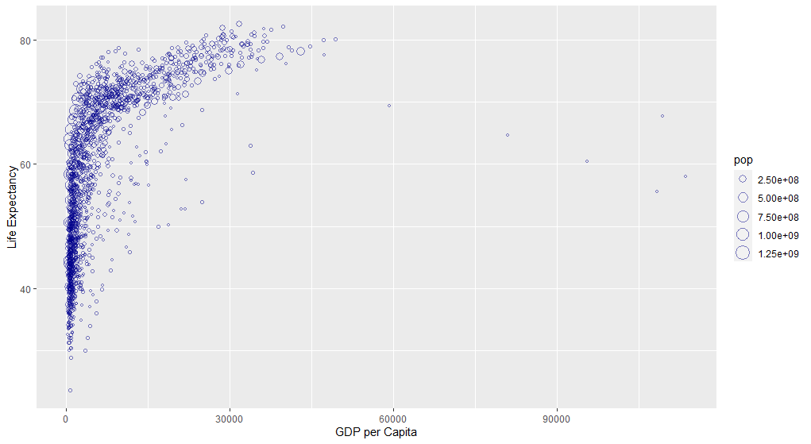

**b: Using Gradient of Red and Green colour as channel to encode Population. Larger population is encoded using red colour and then gradient is used to show lesser population.**

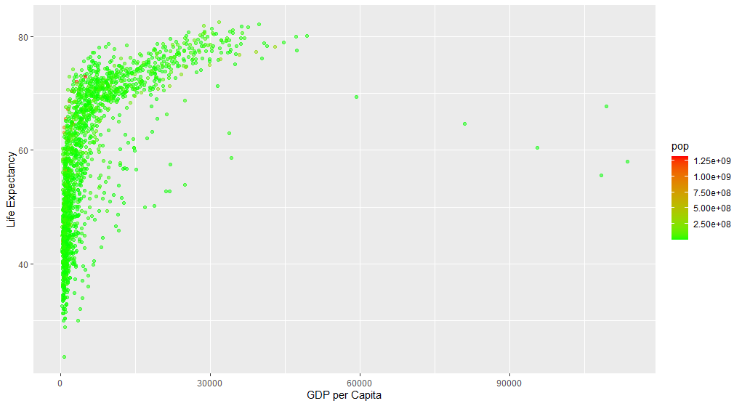

**c: Using Brightness as channel to encode Population. More brightness means higher population**

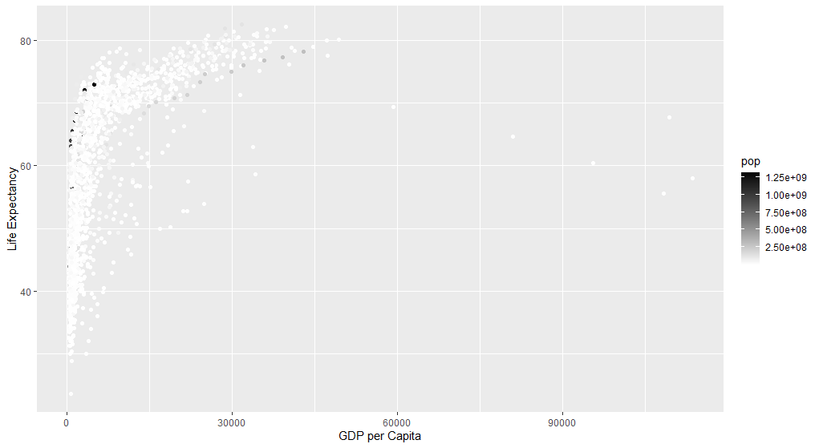

**Part 3: To create a single visualization encodes all 6 attributes in one chart, I have used a animation to plot all 6 attributes together. For this, I have used plotly library to highlight all the 6 attributes. Here, I have used gdpPercap on x axis, lifeExp on y axis, color the points using continent, added animation frames based on years, size of the points based on population and provided country name in the small popup that comes on hover over the point**

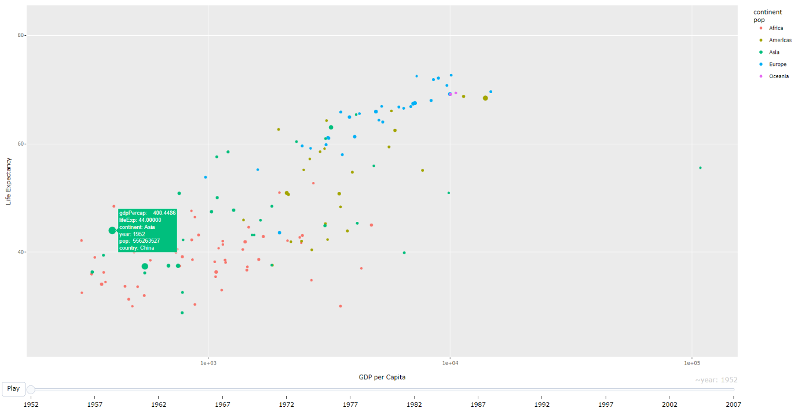

**Link to the Animation:**

[**https://drive.google.com/file/d/1sqCKI82rVgXp3u6lgiM0bHRYDS7_qI8T/view?usp=sharing**](https://drive.google.com/file/d/1sqCKI82rVgXp3u6lgiM0bHRYDS7_qI8T/view?usp=sharing)

Also, I have attached code along with this report where I have added comments on each line and tried to explain the purpose of each line of code

**References**

* GGPLOT2: <https://cran.r-project.org/web/packages/ggplot2/index.html>